Website Planning Document

The Mountain Spoke

Author: Joe Hayes

**Site Purpose**

The purpose of this site is to provide a fresh new website experience for their clients and potential clients that reflects their culture of bicycle enthusiasm with products, repair service, parts, and tour trips.

**Target Audience**

The target audience for this site is bicycle enthusiasts in the Bozeman, Montana region. According to sacredrides.com, some of the characteristics of a mountain biker are as follows: determined, have a sense of adventure, focused, can laugh at themselves, risk-takers, passionate, and they respect the natural environment. Almost all of the growth in bicycling in the U.S. over the past two decades has been among men between 25-64 years old. *Pucher, J., et al., 2011* - [*Bicycling renaissance in North America? An update and re-appraisal of cycling trends and policies, Transportation Research A, 45, in press*](http://vtpi.org/pucher3.pdf)

**Site Map**

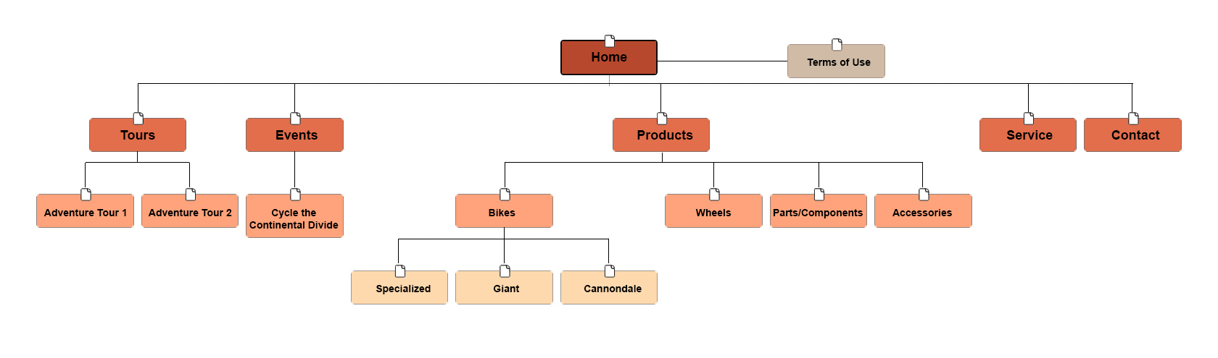

**Color Scheme**

I chose a warm color scheme along with a couple earth-tones since the target audience obviously enjoys being out in nature. The lighter brown color will be used for the nav bar and footer as well as any page divisions. The darker brown will be used for <h1> - <h3> text. Red is exciting, energetic, and sometimes dangerous, just like mountain biking. It will be used for drawing the viewer’s attention to important elements. Yellow will be used for any submit or call to action buttons.



**#000000**

**#fbee01 #f8942e #be4926 #ff0000 #ffffff #7d7d7d**

**Typography**

The font needs to be unique, clean, and professional. Having a name like “Cabin” makes it perfect for outdoor enthusiasts. <link href="https://fonts.googleapis.com/css?family=**Cabin**" rel="stylesheet">

|  |  |  |  |  |
| --- | --- | --- | --- | --- |
| Site header | Cabin | 40px | **#f8942e** | Sample |
| Primary Navigation | Cabin | 18px | **#f8942e** | Sample |
| Footer Navigation | Cabin | 12px | **#f8942e** | Sample |
| Heading 1 (h1) | Cabin | 30px | **#be4926** | Sample |
| Heading 2 (h2) | Cabin | 25px | **#be4926** | Sample |
| Heading 3 (h3) | Cabin | 20px | **#be4926** | Sample |
| Paragraph text (p) | Cabin | 16px | **#000000** | Sample |

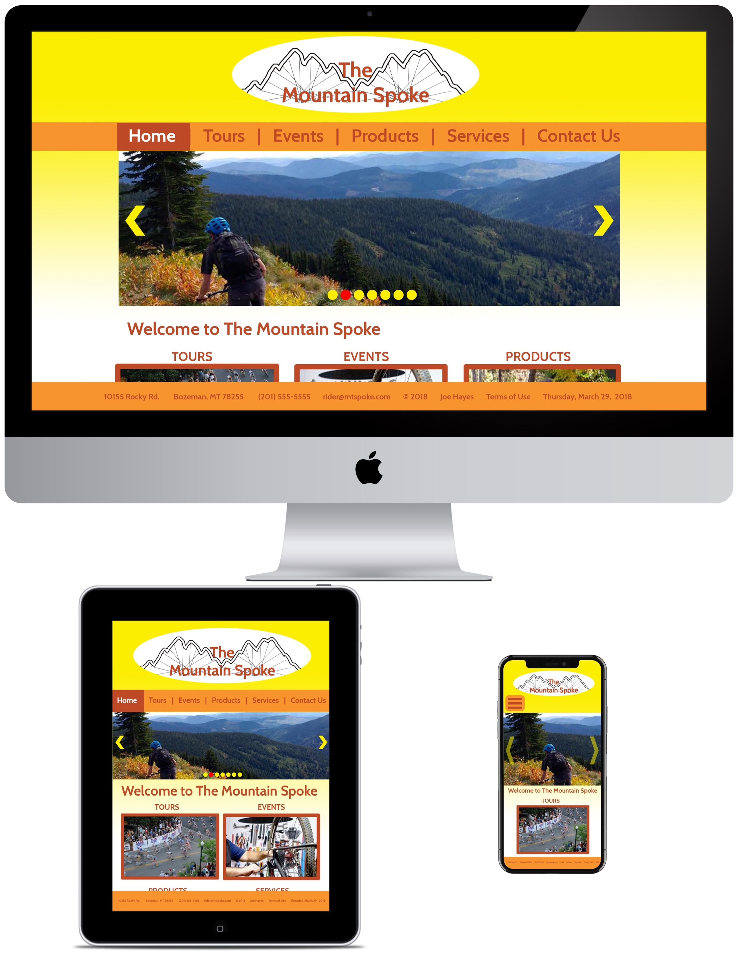**Wire-Frame Sketches**